WEEK 3 – LETSDEFEND LESSON WRITEUP
Lesson 1: How to Investigate a SIEM Alert

1. Aim
To understand a structured approach for investigating security alerts generated by a Security Information and Event Management (SIEM) system, validating suspicious activity, and deciding the appropriate next action.

2. Introduction
A SIEM solution collects and correlates security-related logs from sources such as endpoints, servers, firewalls, identity systems, and network devices. It analyzes these events and can generate alerts when activity matches a rule or suspicious pattern. An alert is an indication that requires investigation; it is not, by itself, proof that an attack has occurred.

3. SIEM Alert Investigation Workflow
- Review the alert: Read the alert name, severity, description, detection time, affected host, user, source and destination IP addresses, and detection rule.
- Understand the detection: Identify what behaviour triggered the alert and what condition the SIEM rule is designed to detect.
- Examine supporting logs: Review related events around the alert time. Check timestamps, event IDs, usernames, hostnames, IP addresses, process names, commands, and other available fields.
- Establish context: Check whether the activity is expected for the user, device, application, time, and business role. Compare it with nearby or historical events when available.
- Correlate evidence: Look for related events across endpoint, authentication, network, DNS, firewall, and other log sources. Build a timeline and determine whether the events are connected.
- Assess the alert: Classify the finding as a true positive, false positive, benign activity, or inconclusive if more information is required.
- Respond or escalate: Follow the organization's playbook. This may involve gathering more evidence, escalating to a senior analyst, or requesting an authorized containment action.
- Document and close: Record the evidence checked, findings, decision, actions taken, and reason for closure or escalation.

4. Important Investigation Details
Item | Why it matters
Timestamp | Establishes when the activity occurred and helps build a timeline.
Source / destination IP | Identifies communicating systems and supports network investigation.
Username / account | Shows which account was involved and whether the activity was expected.
Hostname / device | Identifies the affected endpoint or server.
Process / command line | Can reveal what program or command was executed.
Related events | Provides context and helps confirm or reject the alert hypothesis.
Severity and rule name | Help prioritize investigation but must be interpreted with the evidence.

5. Common Investigation Outcomes
- True positive – The alert correctly identifies suspicious or malicious activity based on the evidence.
- False positive – The detection triggered, but the activity does not meet the threat condition.
- Benign / expected activity – The activity is legitimate and expected, such as an authorized administrative task.
- Inconclusive / needs more investigation – Available evidence is insufficient; further checks or escalation are required.

6. Example Investigation
Illustrative scenario: A SIEM generates an alert for multiple failed login attempts against a user account. The analyst checks the alert time, account name, source IP address, target host, and authentication logs. The analyst checks whether a successful login followed the failures, whether the source is known, and whether the user confirms the activity. The analyst documents the evidence and follows the organization's response procedure. This is an example, not a record of an actual LetsDefend case.

7. Key Learnings
- A SIEM alert must be investigated and validated; severity alone does not confirm an incident.
- Alert details provide the starting point for an investigation.
- Related logs and event correlation help build a clearer picture of activity.
- Analysts should assess context, not just isolated events.
- Investigation decisions must be supported by evidence and documented clearly.
- Escalation and containment should follow organizational procedures and authorization.

8. Conclusion
This lesson introduced a structured method for investigating SIEM alerts. By reviewing alert details, examining supporting logs, correlating events, assessing context, and documenting findings, a SOC analyst can make a more reliable decision about whether an alert represents a security incident.

9. Completion Evidence
Insert a screenshot from LetsDefend showing that “How to Investigate a SIEM Alert” is completed. Do not use a sample or unrelated screenshot.

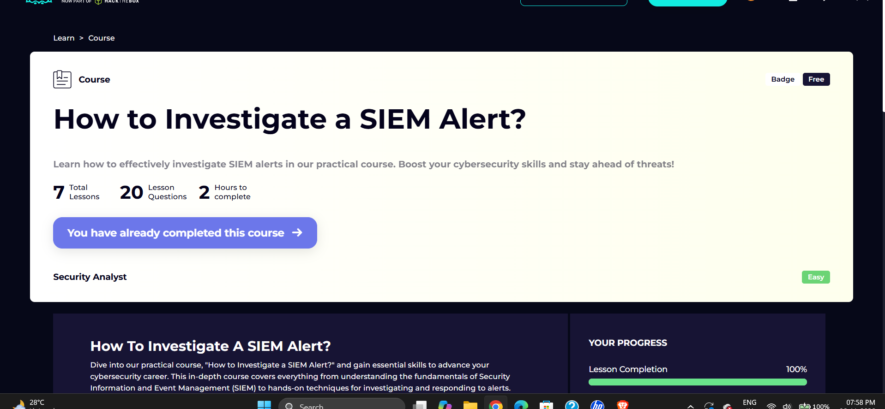10. Learner Notes
Add any specific tools, examples, quiz points, or investigation steps shown in the LetsDefend lesson. This writeup is a general study writeup based on the lesson title and standard SIEM investigation practice; it has not been checked against the exact lesson transcript or your account's lesson content.

